PUBLIC NOTICE

PLEASE TAKE NOTICE THAT THE NASSAU COUNTY LEGISLATURE WILL HOLD COMMITTEE MEETINGS OF THE LEGISLATURE ON WEDNESDAY, NOVEMBER 13, 2024 STARTING AT 1:00 PM AND WILL HOLD A FULL SESSION OF THE LEGISLATURE ON MONDAY, NOVEMBER 20, 2024 STARTING AT 1:00 PM FOR PRESENTATIONS AND PUBLIC COMMENT, AND AT 2:00 PM FOR THE LEGISLATIVE CALENDAR IN THE PETER J. SCHMITT MEMORIAL LEGISLATIVE CHAMBER, 1st FLOOR, THEODORE ROOSEVELT EXECUTIVE AND LEGISLATIVE BUILDING, 1550 FRANKLIN AVENUE, MINEOLA, NEW YORK 11501.

FULL LEGISLATIVE SESSION…………………….1:00 PM

COMMITTEES | TIME
RULES | 1:00PM
PUBLIC SAFETY | 1:00PM
PLANNING, DEVELOPMENT & THE ENVIRONMENT | 1:00PM
TOWNS, VILLAGES AND CITIES | 1:00PM
ECONOMIC AND COMMUNITY DEVELOPMENT, LABOR AND TRANSPORTATION COMMITTEE | 1:00PM
PUBLIC WORKS AND PARKS | 1:00PM
HEALTH AND SOCIAL SERVICES | 1:00PM
GOVERNMENT SERVICES AND OPERATIONS | 1:00PM
MINORITY AFFAIRS | 1:00PM
VETERANS | 1:00PM
SENIOR AFFAIRS | 1:00PM
FINANCE | 1:00PM

MICHAEL C. PULITZER Clerk of the Legislature

Mineola, NY

As per the Nassau County Fire Marshal’s Office, the Peter J. Schmitt Memorial Legislative Chamber has a maximum occupancy of 200 people.
Attendees who would like to address the Legislature must submit a slip to the Clerk’s office staff. Public comment is limited to three minutes per person. At meetings of the full Legislature, public comment will be heard only during the pre-calendar public comment period and during public hearings that are on the calendar. At meetings of the Legislature’s committees, there is no pre-calendar public comment period. Public comment will be heard on agenda items. Public comment on any item may be emailed to the Clerk of the Legislature at LegPublicComment@nassaucountyny.gov and will be made part of the formal record of this Legislative meeting.

The Nassau County Legislature is committed to making its public meetings accessible to individuals with disabilities and every reasonable accommodation will be made so that they can participate. Please contact the Office of the Clerk of the Legislature at 571-4252, or the Nassau County Office for the Physically Challenged at 227-7101 or TDD Telephone No. 227-8989 if any assistance is needed. Every Legislative meeting is streamed live on http://www.nassaucountyny.gov/agencies/Legis/index.html
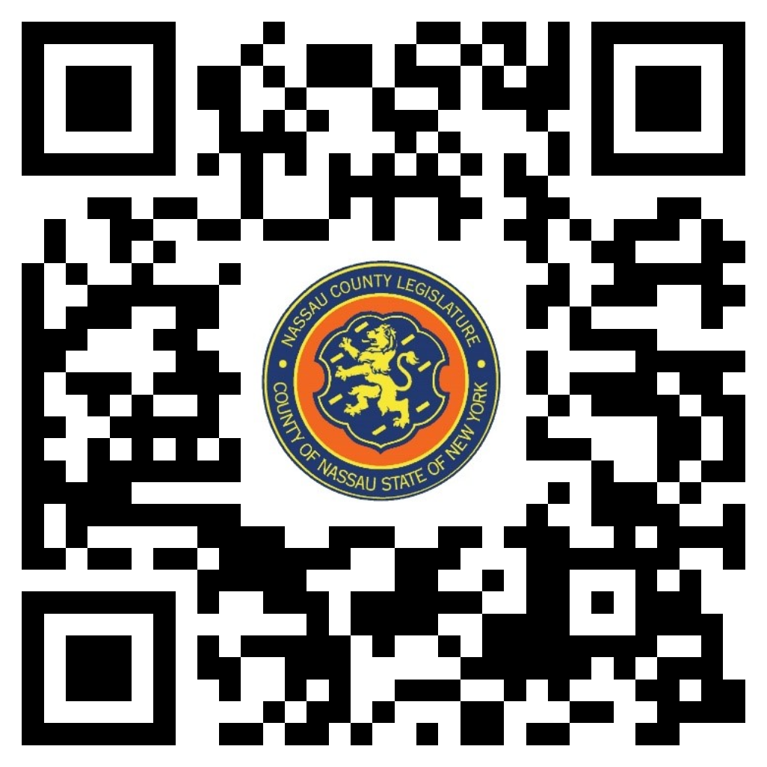
Scan the QR code to submit written public comment,
which will be incorporated into the record of this meeting.

