

PUBLIC NOTICE

PLEASE TAKE NOTICE THAT
THE NASSAU COUNTY LEGISLATURE WILL HOLD

A MEETING OF THE RULES COMMITTEE

ON

MONDAY, DECEMBER 18, 2023 AT 2:00 PM

IN
THE PETER J. SCHMITT MEMORIAL LEGISLATIVE CHAMBER
THEODORE ROOSEVELT EXECUTIVE AND LEGISLATIVE BUILDING
1550 FRANKLIN AVENUE, MINEOLA, NEW YORK 11501

As per the Nassau County Fire Marshal’s Office, the Peter J. Schmitt Memorial Legislative Chamber has a maximum occupancy of 200 people.
Attendees who would like to address the Legislature must submit a slip to the Clerk’s office staff. Public comment is limited to three minutes per person. At meetings of the full Legislature, public comment will be heard only during the pre-calendar public comment period and during public hearings that are on the calendar. At meetings of the Legislature’s committees, there is no pre-calendar public comment period. Public comment will be heard on agenda items. Public comment on any item may be emailed to the Clerk of the Legislature at LegPublicComment@nassaucountyny.gov and will be made part of the formal record of this Legislative meeting.

The Nassau County Legislature is committed to making its public meetings accessible to individuals with disabilities and every reasonable accommodation will be made so that they can participate. Please contact the Office of the Clerk of the Legislature at 571-4252, or the Nassau County Office for the Physically Challenged at 227-7101 or TDD Telephone No. 227-8989 if any assistance is needed. Every Legislative meeting is streamed live on http://www.nassaucountyny.gov/agencies/Legis/index.html
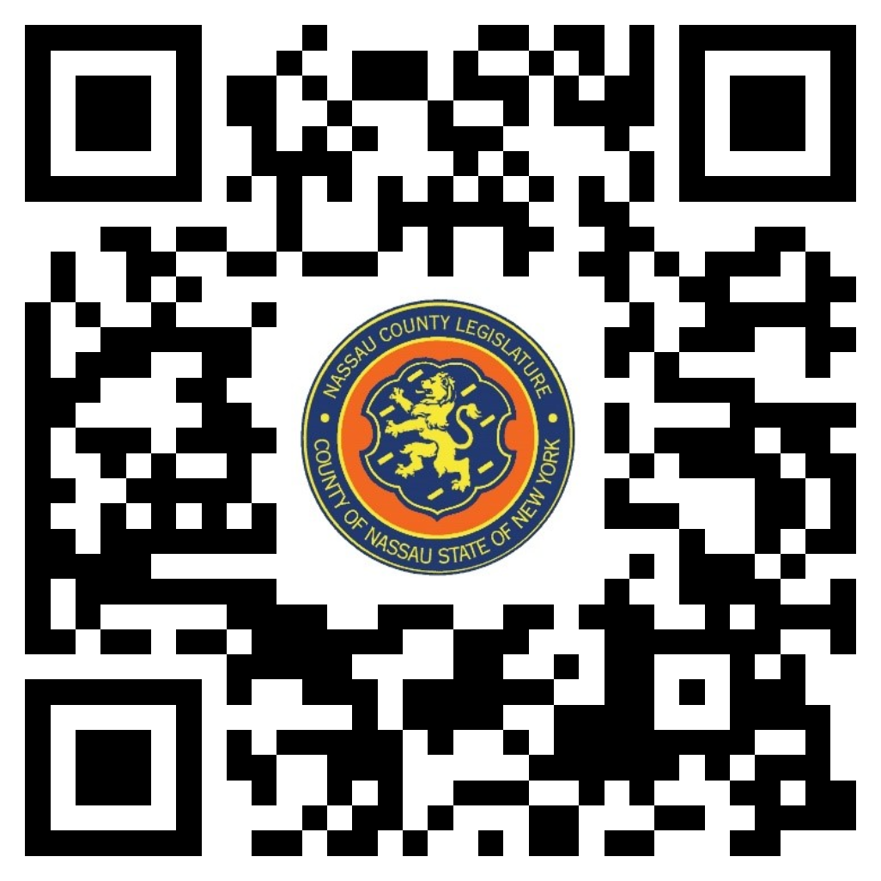
MICHAEL C. PULITZER

Clerk of the Legislature

Nassau County, New York

DATED: December 11, 2023
Mineola, NY

Scan the QR code to submit written public comment,
which will be incorporated into the record of this meeting.

