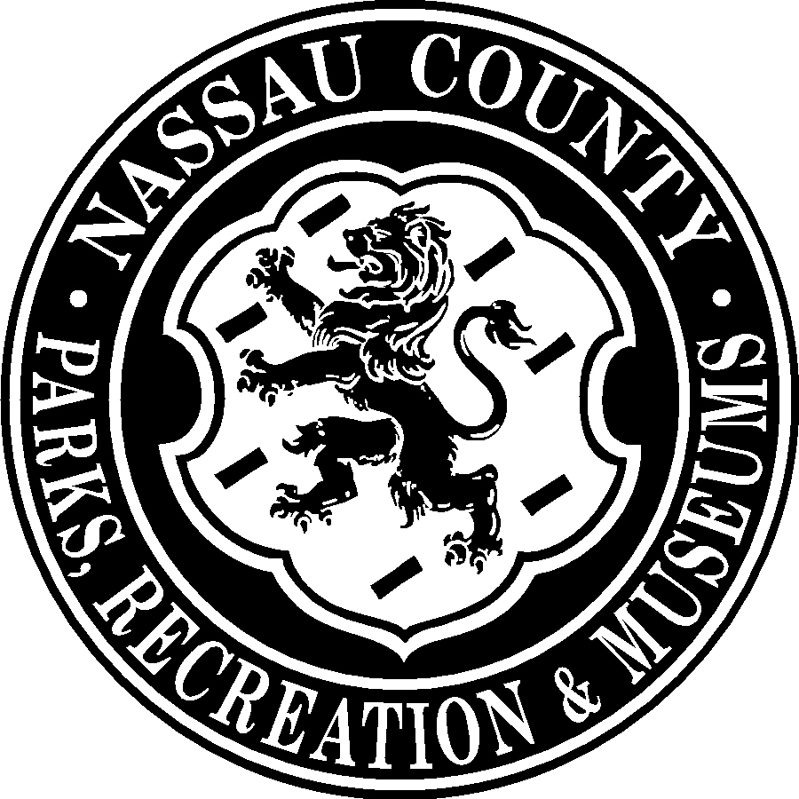
EDWARD P. MANGANO
COUNTY EXECUTIVE
BRIAN NUGENT
CHIEF DEPUTY
COMMISSIONER

COUNTY OF NASSAU
DEPARTMENT OF PARKS, RECREATION AND MUSEUMS
WANTAGH PARK c/o EISENHOWER PARK – EAST MEADOW, NEW YORK 11554
PHONE: 516-571-7460 FAX: 516-571-7467
www.nassaucountyny.gov
HOW CAN I GET A SLIP?

Any Slip Openings during the 2015 Season Are Awarded From the Existing 2015 Lottery List.

Current Seasonal Slip holders have a renewal period from January 2nd- January 31st 2015.

Any Slip Not Paid For Within That Period Becomes Part Of The 2015 Lottery Inventory.

Lottery applications will be accepted January 2nd, 2015 through March 13th, 2015 until 3:00pm.

The Lottery Drawing Will Be Held on Saturday, March 14th, 2015 at 10:00am.

Required Material To Be Submitted With Lottery Application:
- Valid Nassau County Leisure Passport
- Valid New York State Driver’s License
- Valid New York State Boat Registration
- Current Residential Tax Or Utility Bill
- $27.00 (Non-Refundable) Application Fee – Cash, Visa, Or MasterCard (No Checks)
- NOTE: Only One Application Per Boat Is Permitted
Seasonal Slip Fees Are Based On the Nassau County Ordinance Fees
And Are Not Pro-Rated If Slip Is Awarded Later In The Season:

2015 MARINA RATES will be as follows:
ELECTRIC/COMMON WATER (B, C, D, E, F, AND G DOCKS)
$80.00 PER FOOT PLUS $110.00 FOR ELECTRIC Minimum of $1,760.00
NON ELECTRIC/COMMON WATER (A, H, I, AND J DOCKS)
$65.00 PER FOOT Minimum of $975.00
For more information, Please call Wantagh Park at 571-7460
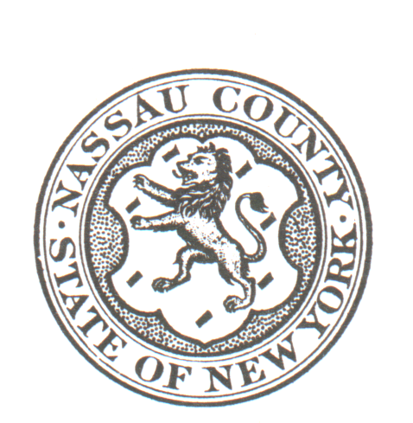
CATEGORY___________________
NON-ELEC ______ELEC________
ENTRY# ______________________
RECTRAC#____________________

NASSAU COUNTY

DEPARTMENT OF PARKS, RECREATION & MUSEUMS

WANTAGH PARK MARINA

2015 SEASONAL LOTTERY APPLICATION

NAME LEISURE PASSPORT #

ADDRESS

TOWN____________________________________ ZIP___________ HOME TELEPHONE #

BOAT REGISTRATION # BOAT MAKE

LENGTH ________ PULPIT OR PLATFORM? Y N BEAM BOAT NAME________________________

THE FOLLOWING MUST BE SUBMITTED WITH THE APPLICATION:
*A $27.00 NON-REFUNDABLE APPLICATION FEE* No Checks………… ___________
*VALID NASSAU COUNTY LEISURE PASSPORT……………............... ___________
*VALID NEW YORK STATE DRIVER LICENSE…………………….…. ___________
*VALID NEW YORK STATE BOAT REGISTRATION…………………. ___________
*MOST RECENT RESIDENTIAL TAX BILL OR UTILITY BILL …….. ___________

*A COPY OF ENDORSEMENT PAGE OF BOAT INSURANCE WITH REQUIRED PROTECTION AND INDEMNITY INSURANCE (aka WATERCRAFT LIABILITY) AS WELL AS HULL INSURANCE WILL BE REQUIRED AT TIME OF SLIP ASSIGNMENT.

Seasonal slip fees are based on the Nassau County Ordinance and are not
Pro-rated if slip is awarded later in the season

$27.00 Lottery Application Fee is non-refundable and not applied toward Seasonal Dockage

ONLY ONE APPLICATION PER BOAT IS PERMITTED

THE LOTTERY DRAWING WILL BE HELD ON SATURDAY, MARCH 14th, 2015 AT 10:00AM
IN THE ROTUNDA AT THE WANTAGH PARK ADMINISTRATION BUILDING.
APPLICATIONS WILL BE ACCEPTED UNTIL FRIDAY, MARCH 13th, 2015 AT 3:00 PM.

PARTICPANTS NEED NOT BE PRESENT. WINNERS WILL BE NOTIFIED.

I hereby apply for the lottery for vacant seasonal slips for the 2013 season. Commercial vehicles and house barges are not eligible for this lottery. Dockage is only for Nassau County residents. If my boat is selected I agree to abide by the terms of the 2015 seasonal contract. Applications are good only for the 2015 lottery and will be discarded October 31st of same year.

The boat that occupies the slip must be the same boat that was entered in the lottery.

_______________________________ _________________________________
Signature of Applicant Approved By / Date

